Certificate of Achievement

This Acknowledges That

Has DemoNStrated ITS COMMITMENT TO LOSS MITIGATION BY COMPLETING ONE Policy Year (April 1, 2015 to april 1, 2016) of NO INCIDENTS/NO Claims as a member of the NRMC Insurance Program

Deborah S. Aschheim  Deborah S. Aschheim, Executive Director |  | 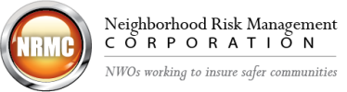

April 2016

