NY Times JANUARY. 20, 2014  Counterintuitive Advice When You Hear ‘Fire!’ in a High-Rise: Stay Put  By MICHAEL SCHWIRTZ | 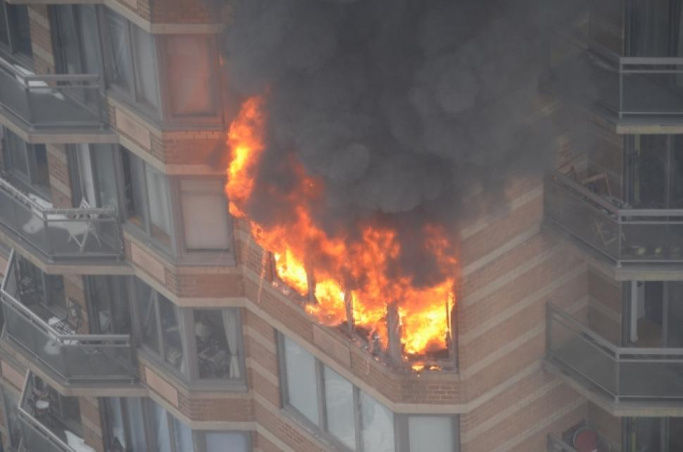

Owen Thompson, who lives across 10th Avenue from the Strand, at 500 West 43rd Street, took photographs as a fire burned on the 20th floor on Jan. 5.
The first clang of the alarm came as many residents of the modern high-rise in Hell’s Kitchen, Manhattan, were sitting down to brunch or opening the Sunday paper. Quickly came the screams — “Fire!”— and an acrid smoke that blackened windows and seeped under doors and through air vents. Few knew exactly where in the 42-story building the fire was. Some tried and failed to reach 911 operators, who were overwhelmed by calls. Many decided to flee.
Daniel McClung was one of them. He and his husband, Michael Cohen, scooped up their two dogs and left their 38th-floor apartment. They reached only the 31st floor before they were overcome by smoke, fire officials said. Mr. McClung, a 27-year-old playwright, died. As of Monday, Mr. Cohen, 32, an online video producer, remained in intensive care at NewYork-Presbyterian/Weill Cornell hospital. Their two dogs, Schooner and Georgia, also died.
As they raced down the stairs, the couple ran into a suffocating plume of smoke sucked upward as if through a chimney when firefighters opened the stairwell door and pushed into the burning apartment.
Had the couple remained in their home, Mr. McClung would have survived, officials said. The fire turned out to be isolated to an apartment 18 floors below where the couple lived. Because the building was constructed of fire-resistant materials, the blaze barely spread. Even residents who remained in apartments directly next door to the fire emerged unscathed.
A fire safety notice that is supposed to be affixed to every entry door makes clear that staying in place is often the safest strategy during a fire. Most residents interviewed after the fire said they had never seen the notice, had seen it long ago, lost it, or, treated it like a safety information card on an airplane, and simply did not read it.
Even among those who knew the rule, many said the first impulse was to run.
The Strand, which opened in the late 1980s, was built with fire-resistant materials, plasterboard walls and metal doors designed to withstand a blaze for up to three hours, the Fire Department said. It does not have sprinklers or an intercom system.
After the fire there, friends of Mr. McClung and Mr. Cohen created a petition on the website change.org calling for legislation that would require residential high-rise buildings to have public address systems to provide timely information in case of an emergency. Corey Johnson, a City Council member whose district includes Hell’s Kitchen, has proposed a bill that would require such systems in buildings over six stories.
“Many people don’t know whether they live in a fireproof building and don’t know whether they should stay or go during an emergency,” Mr. Johnson said at a news conference last week. “Daniel’s life would have been saved if he had stayed in his apartment, but he wasn’t given proper instructions when the fire broke out.”

